**Project Specification Document**

Inwerken

Connor Fradenburgh

Derek Boonstra

Tanner  Olason

Victor Rauta

**Table of Contents**

Section Page

[1. Project Vision and Objectives 1](https://docs.google.com/document/d/1MMaaMX2fZlGFJ2EbqOgzRI6t9QrPdSjuxAMCjYDaEoA/edit#heading=h.30j0zll)

[1.1 Project Scope and Vision 1](https://docs.google.com/document/d/1MMaaMX2fZlGFJ2EbqOgzRI6t9QrPdSjuxAMCjYDaEoA/edit#heading=h.1fob9te)

[1.2 Project Goals and Objectives 1](https://docs.google.com/document/d/1MMaaMX2fZlGFJ2EbqOgzRI6t9QrPdSjuxAMCjYDaEoA/edit#heading=h.3znysh7)

[2. Project Planning 2](https://docs.google.com/document/d/1MMaaMX2fZlGFJ2EbqOgzRI6t9QrPdSjuxAMCjYDaEoA/edit#heading=h.2et92p0)

[2.1 Project Lifecycle 2](https://docs.google.com/document/d/1MMaaMX2fZlGFJ2EbqOgzRI6t9QrPdSjuxAMCjYDaEoA/edit#heading=h.tyjcwt)

[2.2 Project Setup 2](https://docs.google.com/document/d/1MMaaMX2fZlGFJ2EbqOgzRI6t9QrPdSjuxAMCjYDaEoA/edit#heading=h.3dy6vkm)

[2.3 Stakeholders 2](https://docs.google.com/document/d/1MMaaMX2fZlGFJ2EbqOgzRI6t9QrPdSjuxAMCjYDaEoA/edit#heading=h.4d34og8)

[2.4 Project Resources 2](https://docs.google.com/document/d/1MMaaMX2fZlGFJ2EbqOgzRI6t9QrPdSjuxAMCjYDaEoA/edit#heading=h.2s8eyo1)

[2.5 Assumptions 2](https://docs.google.com/document/d/1MMaaMX2fZlGFJ2EbqOgzRI6t9QrPdSjuxAMCjYDaEoA/edit#heading=h.17dp8vu)

[3. Project Tracking 3](https://docs.google.com/document/d/1MMaaMX2fZlGFJ2EbqOgzRI6t9QrPdSjuxAMCjYDaEoA/edit#heading=h.26in1rg)

[3.1 Tracking 3](https://docs.google.com/document/d/1MMaaMX2fZlGFJ2EbqOgzRI6t9QrPdSjuxAMCjYDaEoA/edit#heading=h.lnxbz9)

[3.2 Communication Plan 3](https://docs.google.com/document/d/1MMaaMX2fZlGFJ2EbqOgzRI6t9QrPdSjuxAMCjYDaEoA/edit#heading=h.35nkun2)

[3.3 Deliverables 4](https://docs.google.com/document/d/1MMaaMX2fZlGFJ2EbqOgzRI6t9QrPdSjuxAMCjYDaEoA/edit#heading=h.3j2qqm3)

[3.4 Project Metrics 4](https://docs.google.com/document/d/1MMaaMX2fZlGFJ2EbqOgzRI6t9QrPdSjuxAMCjYDaEoA/edit#heading=h.1y810tw)

[4. Requirements (User Stories) 5](https://docs.google.com/document/d/1MMaaMX2fZlGFJ2EbqOgzRI6t9QrPdSjuxAMCjYDaEoA/edit#heading=h.2xcytpi)

[4.1 Overall Description 5](https://docs.google.com/document/d/1MMaaMX2fZlGFJ2EbqOgzRI6t9QrPdSjuxAMCjYDaEoA/edit#heading=h.1ci93xb)

[4.2 Users and Roles 5](https://docs.google.com/document/d/1MMaaMX2fZlGFJ2EbqOgzRI6t9QrPdSjuxAMCjYDaEoA/edit#heading=h.3whwml4)

[4.3 Use Case Diagrams 5](https://docs.google.com/document/d/1MMaaMX2fZlGFJ2EbqOgzRI6t9QrPdSjuxAMCjYDaEoA/edit#heading=h.2bn6wsx)

[4.4 User Stories (Requirements) 5](https://docs.google.com/document/d/1MMaaMX2fZlGFJ2EbqOgzRI6t9QrPdSjuxAMCjYDaEoA/edit#heading=h.qsh70q)

[4.5 Constraints and Limitations 10](https://docs.google.com/document/d/1MMaaMX2fZlGFJ2EbqOgzRI6t9QrPdSjuxAMCjYDaEoA/edit#heading=h.3as4poj)

[5. Design 11](https://docs.google.com/document/d/1MMaaMX2fZlGFJ2EbqOgzRI6t9QrPdSjuxAMCjYDaEoA/edit#heading=h.1pxezwc)

[5.1 Introduction 11](https://docs.google.com/document/d/1MMaaMX2fZlGFJ2EbqOgzRI6t9QrPdSjuxAMCjYDaEoA/edit#heading=h.49x2ik5)

[5.2 Scope 11](https://docs.google.com/document/d/1MMaaMX2fZlGFJ2EbqOgzRI6t9QrPdSjuxAMCjYDaEoA/edit#heading=h.2p2csry)

[5.3 High-Level Component Design 11](https://docs.google.com/document/d/1MMaaMX2fZlGFJ2EbqOgzRI6t9QrPdSjuxAMCjYDaEoA/edit#heading=h.147n2zr)

[5.4 Class Diagram 11](https://docs.google.com/document/d/1MMaaMX2fZlGFJ2EbqOgzRI6t9QrPdSjuxAMCjYDaEoA/edit#heading=h.3o7alnk)

[5.5 Activity Diagrams 11](https://docs.google.com/document/d/1MMaaMX2fZlGFJ2EbqOgzRI6t9QrPdSjuxAMCjYDaEoA/edit#heading=h.23ckvvd)

[5.6 Sequence Diagram 11](https://docs.google.com/document/d/1MMaaMX2fZlGFJ2EbqOgzRI6t9QrPdSjuxAMCjYDaEoA/edit#heading=h.ihv636)

[5.7 Alternative Designs and Design Rationale 11](https://docs.google.com/document/d/1MMaaMX2fZlGFJ2EbqOgzRI6t9QrPdSjuxAMCjYDaEoA/edit#heading=h.32hioqz)

[5.8 Data Architecture 11](https://docs.google.com/document/d/1MMaaMX2fZlGFJ2EbqOgzRI6t9QrPdSjuxAMCjYDaEoA/edit#heading=h.41mghml)

[6. User Interface 12](https://docs.google.com/document/d/1MMaaMX2fZlGFJ2EbqOgzRI6t9QrPdSjuxAMCjYDaEoA/edit#heading=h.vx1227)

[6.1 UI Description 12](https://docs.google.com/document/d/1MMaaMX2fZlGFJ2EbqOgzRI6t9QrPdSjuxAMCjYDaEoA/edit#heading=h.3fwokq0)

[6.2 UI Mockup 12](https://docs.google.com/document/d/1MMaaMX2fZlGFJ2EbqOgzRI6t9QrPdSjuxAMCjYDaEoA/edit#heading=h.1v1yuxt)

[7. Project Closure 13](https://docs.google.com/document/d/1MMaaMX2fZlGFJ2EbqOgzRI6t9QrPdSjuxAMCjYDaEoA/edit#heading=h.4f1mdlm)

[7.1 Goals / Vision 13](https://docs.google.com/document/d/1MMaaMX2fZlGFJ2EbqOgzRI6t9QrPdSjuxAMCjYDaEoA/edit#heading=h.2u6wntf)

[7.2 Delivered Solution 13](https://docs.google.com/document/d/1MMaaMX2fZlGFJ2EbqOgzRI6t9QrPdSjuxAMCjYDaEoA/edit#heading=h.19c6y18)

[7.3 Remaining Work 13](https://docs.google.com/document/d/1MMaaMX2fZlGFJ2EbqOgzRI6t9QrPdSjuxAMCjYDaEoA/edit#heading=h.3tbugp1)

[8. Definitions and Acronyms 14](https://docs.google.com/document/d/1MMaaMX2fZlGFJ2EbqOgzRI6t9QrPdSjuxAMCjYDaEoA/edit#heading=h.28h4qwu)

# 1. Project Vision and Objectives

## 1.1 Project Scope and Vision

This project is to develop a prototype of a portal that the Kannegiesser company will provide for their customers. Currently, Kannegiesser is using a portal that is made by a different company, and Inwerken plans on presenting them with a new portal for them to use. If this project succeeds, then Inwerken will work with Kannegiesser to fully develop the portal and continue to support the portal. In this portal, customers will have an overview of their machines and will include features including a spare parts web-shop and a video-center. One of the features that this project will be focusing on is a maintenance cockpit, which will carry out maintenance activities and tasks on the customers machines. The maintenance cockpit will contain two views; a machine view, that displays all of a customer’s machines at all of their plants, and an order view, which shows the customer all of their orders.

## 1.2 Project Goals and Objectives

|  |  |
| --- | --- |
| **#** | **Goal or Objective** |
| 1 | Make the prototype extensible - there are plans to further develop and those updates should be easy to implement |
| 2 | Make the prototype easy to support - it is important that we provide good documentation and all necessary source code so work can continue on the project in the future |
| 3 | Develop an easy to use prototype - users must be able to use the portal with minimal to no training |
| 4 | Learn more about what working with a company on a software project is like |
| 5 | Develop better communication skills |
| 6 | Have fun working on the project |

# 2. Project Planning

## 2.1 Project Lifecycle

Our team will use an agile approach with 4 sprints of 3 weeks each. There will also be a weekly meeting with the sponsors so we can keep them up to date with what we are working on. We will be provided requirements but will follow up with our mentors to make sure everything is understood. The team will emphasise a SCRUM approach to make sure there are frequent meetings and that collaboration is important.

## 2.2 Project Setup

|  |  |
| --- | --- |
| **#** | **Decision Description** |
| 1 | Windows 8, PHP, CSS, Frameworks, SAP, REST-Services |
| 2 | Prototype will be available on all browsers |
| 3 | Trac and Git |
| 4 | Default Capstone coding standard |

## 2.3 Stakeholders

|  |  |
| --- | --- |
| **Stakeholder** | **Role** |
| Inwerken | Sponsor |
| Bastian Bachmann | Mentor |
| Maxim Regan | Mentor |
| Alex Radermacher | Instructor |
| Dean Knudson | Instructor |
| Connor Fradenburgh | Team Member |
| Derek Boonstra | Team Member |
| Tanner Olason | Team Member |
| Victor Rauta | Team Member |
| Kannegiesser | Client |

## 2.4 Project Resources

|  |  |  |
| --- | --- | --- |
| **Resource** | **Resource Description** | **Quantity** |
| Capstone Team | The team of students who are the primary developers on this project | 4 |
| SAP Gateway | Used for communication between front-end and back-end | 1 |
| Bastian Bachmann and Maxim Regan | Mentors who will be able to answer any questions we may have | 2 |
| Workstation with Internet Access | Must be able to connect and test the prototype | 4 |

## 2.5 Assumptions

|  |  |
| --- | --- |
| **#** | **Assumption** |
| A1 | Capstone Team and mentors will meet on Skype once a week |
| A2 | Test data will be provided for the front-end work |
| A3 | Team members will have completed the SAPU15 tutorial by the beginning of February |
| A4 | Team members will put in as much effort as they can to ensure there is a working prototype by the end of the semester |

# 3. Project Tracking

## 3.1 Tracking

|  |  |  |
| --- | --- | --- |
| **Information** | **Description** | **Link** |
| Code Storage | The project code will be stored in a SVN repository | [Link](https://csprojects.cs.ndsu.nodak.edu/csci445/2018/spring/csci445s18inwerken/svn/) |
| Bug Tracking | Bug tracking will be done with Trac | [Link](https://csprojects.cs.ndsu.nodak.edu/csci445/2018/spring/csci445s18inwerken/trac/) |
| Project Documents and Assignments | Weekly reports, specification and design documents, etc. will be stored in our SVNrepository | [Link](https://csprojects.cs.ndsu.nodak.edu/csci445/2018/spring/csci445s18inwerken/svn/) |
|  |  |  |
|  |  |  |

## 3.2 Communication Plan

**Regularly Scheduled Meetings**

|  |  |  |
| --- | --- | --- |
| **Meeting Type** | **Frequency/Schedule** | **Who Attends** |
| Conference Call on Skype | Weekly | Project team and mentors |
| Team Meeting | Weekly | Project team |
| Short Meeting | Weekly in class | Project Team |
| Sprint Planning Meeting | Start of each sprint (during conference call) | Project team and mentors |
| Sprint Retrospective Meeting | End of each sprint (during Team Meeting) | Project team |
| Sprint Review Meeting | End of each sprint (during conference call) | Project team and mentors |

**Information To Be Shared Within Our Group**

|  |  |  |  |
| --- | --- | --- | --- |
| **Who?** | **What Information?** | **When?** | **How?** |
| Project Team | Task assignments & scrum information | Weekly | Team meetings |
|  |  |  |  |

**Information To Be Provided To Other Groups**

|  |  |  |  |
| --- | --- | --- | --- |
| **Who?** | **What Information?** | **When?** | **How?** |
| Sponsor and Mentors | Final deliverables | At completion of project | Project specification doc, code, Powerpoint presentation |
| Mentors | Weekly report | Weekly | Email and Trac site access |
|  |  |  |  |

**Information Needed From Other Groups**

|  |  |  |  |
| --- | --- | --- | --- |
| **Who?** | **What Information?** | **When?** | **How?** |
| Sponsor and mentors | Requirement changes | Start of each sprint | Conference call |
| Mentors | Issues and concerns | Start of each sprint | Conference call |

## 3.3 Deliverables

|  |  |
| --- | --- |
| **#** | **Deliverable** |
| 1 | Code |
| 2 | Test results |
| 3 | Postmortem document |
| 4 | Final report |

## 3.4 Project Metrics

|  |  |  |
| --- | --- | --- |
| **Metric** | **Frequency** | **Location** |
| Estimated User Story Points | Per Sprint at the start of each sprint | At the beginning of Individual Sprint (Section 4.5) |
| Actual User Story Points Completed (Velocity) | Per Sprint at the end of each sprint | At the beginning of Individual Sprint (Section 4.5) |

# 4. Requirements (User Stories)

## 4.1 Overall Description

This project is a prototype collaboration between the NDSU-based team and the Inwerken team in Germany. It is intended to be used as a management portal for the Herbert Kannegiesser GmbH company. The project involves a website front end that the NDSU team will be working on, as well as a back-end database that the Inwerken team will work on in parallel. There is also a gateway portal to work between the two projects.

This project is meant to be a prototyped demonstration developed with HTML5 along with Javascript based framework SAP UI5 for Kannegiesser. The project is meant to help users maintain and plan orders for various machines they manage.

The front-end website will display two main views, a Machine view and an Order view. The Machine view will allow the user to view a master list of all machines that exist in a location, as well as map scheduled maintenance and inspections in an orderly fashion.

The Order view will display open orders sorted by priority and due date as well as machine names and numbers. There will be an option for more details of each order, as well as options to process reports back to customers.

## 4.2 Users and Roles

|  |  |
| --- | --- |
| **User** | **Description** |
| Developer | A Capstone team member or mentor who is managed with creating the prototype or dealing with the back-end data |
| Inwerken Company | Members of the Inwerken company that will be continuing to add on to the prototype in the future |
| Kannegiesser | The customer of the prototype that may use this prototype as their portal |
| Kannegiesser customers | The users of this prototype who will interact with the portal to gain necessary information about their machines |
|  |  |
|  |  |
|  |  |

## 4.3 Use Case Diagrams

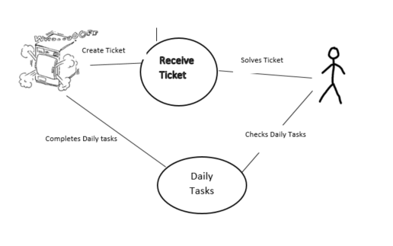

## 4.4 User Stories (Requirements)

|  |  |  |
| --- | --- | --- |
| **ID** | **Feature** | **Story Points** |
| 1 | View the maintenance cockpit | 5 |
| 2 | View the machine view page | 8 |
| 3 | View list of open orders | 8 |
| 4 | Process is reported back to user (Checkbox per procedure) | 3 |
| 5 | Define user parameters that allow/forbid processing of certain maintenance steps | 5 |
| 6 | Urgent repair orders displayed via Web-socket message directly in app | 8 |
| 7 | Ability to watch maintenance videos | 5 |
| 8 | Give feedback | 3 |
| 9 | Change language to German | 5 |
| 10 | Login page | 5 |

**SPRINT 1**

**Total Estimated User Story Points for Sprint 1: 5**

**Actual Completed User Story Points for Sprint 1:**

|  |  |  |  |  |  |  |  |
| --- | --- | --- | --- | --- | --- | --- | --- |
| **ID** | **Added** | **Description** | **Status** | **Story Points** | **Actual Equivalent Story Points** | | **% Completed** |
| 1 | Onset | **As a** Kannegiesser customer  **I want** to be able to view the maintenance cockpit  **So that** I can carry out maintenance activities on tasks and machines | C | 5 |  | | 90% |
| **Acceptance Criteria** | | | **Verification** | | | | |
| 1.1 | Users are able to carry out tasks and activities | | The user is able to access tasks and activities and complete these | | | | |
| 1.2 | There is a printable and mobile friendly checklist for activities/tasks | | Works on mobile and able to print | | | | |
| 1.3 | Cockpit has two entry views | | Clicking on these views takes you to relevant page | | | | |
| 1.4 | User is emailed of any maintenance with high priority | | Make sure emails are sent out on maintenance that has a certain condition met. | | | | |
| **ID** | **Tasks** | | | | | **Resource** | |
| 1 | Create the maintenance cockpit | | | | | Connor | |
| 2 | Create the two entry views | | | | | Derek | |
|  |  | | | | |  | |
|  |  | | | | |  | |
|  |  | | | | |  | |

**SPRINT 2**

**Total Estimated User Story Points for Sprint 2: 13**

**Actual Completed User Story Points for Sprint 2:**

|  |  |  |  |  |  |  |  |
| --- | --- | --- | --- | --- | --- | --- | --- |
| **ID** | **Added** | **Description** | **Status** | **Story Points** | **Actual Equivalent Story Points** | | **% Completed** |
| 2 | Onset | **As** a Kannegiesser customer,  **I want** to be able to view my machines,  **So that** I can perform necessary tasks and receive information about my machines | C | 8 |  | | 90% |
| **Acceptance Criteria** | | | **Verification** | | | | |
| 2.1 | All machines will be displayed at all plants. | | Compare to data | | | | |
| 2.2 | All inspections/checks that a customer has are mapped | | Check to see if inspections/checks are all present | | | | |
| 2.3 | Able to select a machine and see relevant info and Maintenance plan | | Machines are selectable and all of the data is shown | | | | |
| 2.4 | List displays future-related, open, or completed orders/maintenance activities | | All activities from the data are displayed | | | | |
| 2.5 | List has a filter | | Filter works | | | | |
| **ID** | **Tasks** | | | | | **Resource** | |
| 1 | Create MasterList page | | | | | Tanner | |
| 2 | Added Filter | | | | | Connor | |
| 3 | Machines are selectable | | | | | Connor | |
|  |  | | | | |  | |
|  |  | | | | |  | |
|  |  | | | | |  | |

|  |  |  |  |  |  |  |  |
| --- | --- | --- | --- | --- | --- | --- | --- |
| **ID** | **Added** | **Description** | **Status** | **Story Points** | **Actual Equivalent Story Points** | | **% Completed** |
| 7 | Onset | **As a** Kannegiesser customer,  **I want** to be able to view maintenance videos,  **so that** I can better understand how to maintain my equipment | **T** | **5** |  | | **0%** |
| **Acceptance Criteria** | | | **Verification** | | | | |
| 7.1 | A user can find a page or portal that contains maintenance videos | | Create a test case that page or portal is reachable and contains videos | | | | |
| 7.2 | A user can view maintenance videos provided | | Create a test case that confirms videos are there and can be viewed | | | | |
|  |  | |  | | | | |
|  |  | |  | | | | |
|  |  | |  | | | | |
| **ID** | **Tasks** | | | | | **Resource** | |
| 1 | Create a video-viewing page or portal | | | | |  | |
| 2 | Place a video that can be viewed for testing purposes | | | | |  | |
|  |  | | | | |  | |
|  |  | | | | |  | |

**SPRINT 3**

**Total Estimated User Story Points for Sprint 3:** 16

**Actual Completed User Story Points for Sprint 3:**

|  |  |  |  |  |  |  |  |
| --- | --- | --- | --- | --- | --- | --- | --- |
| **ID** | **Added** | **Description** | **Status** | **Story Points** | **Actual Equivalent Story Points** | | **% Completed** |
| 3 | Onset | **As a** Kannegiesser customer,  **I want** to be able to view my orders,  **So that** I can perform necessary tasks and receive information about my machines | C | 8 |  | | 90% |
| **Acceptance Criteria** | | | **Verification** | | | | |
| 3.1 | Must show all open orders, sorted by priority | | All of the orders in the database are present | | | | |
| 3.2 | Must be able to select an order and see the detail view | | Order is selectable and shows info | | | | |
| 3.3 | Must be an info button that contains information about instructions, tutorials, or videos | | There should be a button that does the required tasks | | | | |
| **ID** | **Tasks** | | | | | **Resource** | |
| 1 | Created a list of the orders | | | | | Connor | |
| 2 | Orders are clickable and show information | | | | | Connor | |
| 3 | Added a filter | | | | | Connor | |
|  |  | | | | |  | |
|  |  | | | | |  | |
|  |  | | | | |  | |
|  |  | | | | |  | |
|  |  | | | | |  | |

|  |  |  |  |  |  |  |  |
| --- | --- | --- | --- | --- | --- | --- | --- |
| **ID** | **Added** | **Description** | **Status** | **Story Points** | **Actual Equivalent Story Points** | | **% Completed** |
| 10 | 3/7/2018 | **As a** Kannegiesser customer  **I want** to be able to login to the portal  **So that** I can perform my tasks | C | 5 |  | | 0 |
| **Acceptance Criteria** | | | **Verification** | | | | |
| 10.1 | Registered users are able to login | | Created users are granted access to the portal | | | | |
| 10.2 | Certain users are denied access to certain parts of the portal | | If a user is not granted access to certain items then those are removed from the portal | | | | |
|  |  | |  | | | | |
| **ID** | **Tasks** | | | | | **Resource** | |
|  |  | | | | |  | |
|  |  | | | | |  | |
|  |  | | | | |  | |
|  |  | | | | |  | |
|  |  | | | | |  | |
|  |  | | | | |  | |
|  |  | | | | |  | |
|  |  | | | | |  | |

|  |  |  |  |  |  |  |  |
| --- | --- | --- | --- | --- | --- | --- | --- |
| **ID** | **Added** | **Description** | **Status** | **Story Points** | **Actual Equivalent Story Points** | | **% Completed** |
| 5 | Onset | **As a** Kannegiesser employee,  **I want** to be able to only the steps I have access to,  **So that** I am unable to access restricted steps | C | 5 |  | | 0% |
| **Acceptance Criteria** | | | **Verification** | | | | |
| 5.1 | Only certain users will be able to access certain maintenance steps | | Users without access cannot access all steps | | | | |
|  |  | |  | | | | |
|  |  | |  | | | | |
|  |  | |  | | | | |
| **ID** | **Tasks** | | | | | **Resource** | |
|  |  | | | | |  | |
|  |  | | | | |  | |
|  |  | | | | |  | |
|  |  | | | | |  | |

**SPRINT 4**

**Total Estimated User Story Points for Sprint 4:**

**Actual Completed User Story Points for Sprint 4:**

|  |  |  |  |  |  |  |  |
| --- | --- | --- | --- | --- | --- | --- | --- |
| **ID** | **Added** | **Description** | **Status** | **Story Points** | **Actual Equivalent Story Points** | | **% Completed** |
| 8 | Onset | **As a** Kannegiesser customer,  **I want** to leave feedback,  **So that** I can tell Kannegiesser how I feel about the website | T | 3 |  | | 0% |
| **Acceptance Criteria** | | | **Verification** | | | | |
| 8.1 | Feedback option on the maintenance cockpit page | | There exists a feedback button | | | | |
| 8.2 | Users are able to enter feedback | | Users can enter feedback | | | | |
| 8.3 | Feedback is sent to Kannegiesser | | Kannegieser received the feedback | | | | |
|  |  | |  | | | | |
| **ID** | **Tasks** | | | | | **Resource** | |
|  |  | | | | |  | |
|  |  | | | | |  | |
|  |  | | | | |  | |
|  |  | | | | |  | |

|  |  |  |  |  |  |  |  |
| --- | --- | --- | --- | --- | --- | --- | --- |
| **ID** | **Added** | **Description** | **Status** | **Story Points** | **Actual Equivalent Story Points** | | **% Completed** |
| 9 | Onset | **As a** Kannegiesser customer,  **I want** to be able to change the language to German,  **So that** I can understand the website | T | 5 |  | | 0% |
| **Acceptance Criteria** | | | **Verification** | | | | |
| 9.1 | All text is translated from English to German | | There is no English text and only German | | | | |
| 9.2 | The translations are almost, if not completely, accurate | | German speaking Inwerken employees will check | | | | |
|  |  | |  | | | | |
|  |  | |  | | | | |
| **ID** | **Tasks** | | | | | **Resource** | |
|  |  | | | | |  | |
|  |  | | | | |  | |
|  |  | | | | |  | |
|  |  | | | | |  | |

|  |  |  |  |  |  |  |  |
| --- | --- | --- | --- | --- | --- | --- | --- |
| **ID** | **Added** | **Description** | **Status** | **Story Points** | **Actual Equivalent Story Points** | | **% Completed** |
| 6 | Onset | **As a** Kannegiesser customer,  **I want** to get a notification message for repairs marked “urgent”,  **so that** I know of high-priority tasks | **T** | **5** |  | | **0%** |
| **Acceptance Criteria** | | | **Verification** | | | | |
| 6.1 | Notifications can be viewed | | There exists a notification area for urgent repairs | | | | |
| 6.2 | User gets notification message | | Users receive urgent messages in-app | | | | |
| 6.3 | Notification area is highly visible | | Users see flashy notification | | | | |
| **ID** | **Tasks** | | | | | **Resource** | |
|  |  | | | | |  | |
|  |  | | | | |  | |
|  |  | | | | |  | |
|  |  | | | | |  | |

## 4.5 Constraints and Limitations

|  |  |
| --- | --- |
| **Constraint** | **ID** |
| We will have to integrate with SAP database so the website must be compatible with that | 101 |
|  |  |
|  |  |

# 5. Design

## 5.1 Introduction

The design for this project is to implement the back-end database with our front-end prototype website using the SAPUI5 framework. Using this connection, the website will display the necessary information. The user will be able to view machines and orders that are received from the database.

## 5.2 Scope

This document is a high level overview of the design decisions and paradigms. Since we are focusing on the front-end, much of the design is being developed in the back-end and we are not privy to that information. The primary component that needs design is the prototype website that will use the SAPUI5 framework. Using a UI, we will connect with the database and the user will be able to view their information.

## 5.3 High-Level Component Design

|  |  |  |
| --- | --- | --- |
| **Component** | **Related Requirements** | **Description** |
| Gateway | 2,3 | This is what will connect the front-end to the back-end which allows the website to display the data |
| SAPUI5 Queries | 2,3 | Allows the user to view the necessary information depending on what is clicked |
|  |  |  |
|  |  |  |

## 5.4 Class Diagram

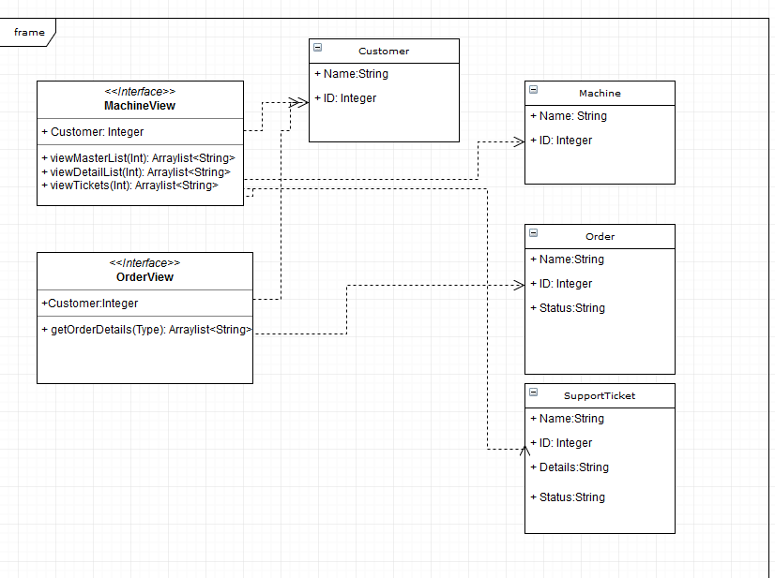

## 5.5 Activity Diagrams

Viewing the details of a ticket:

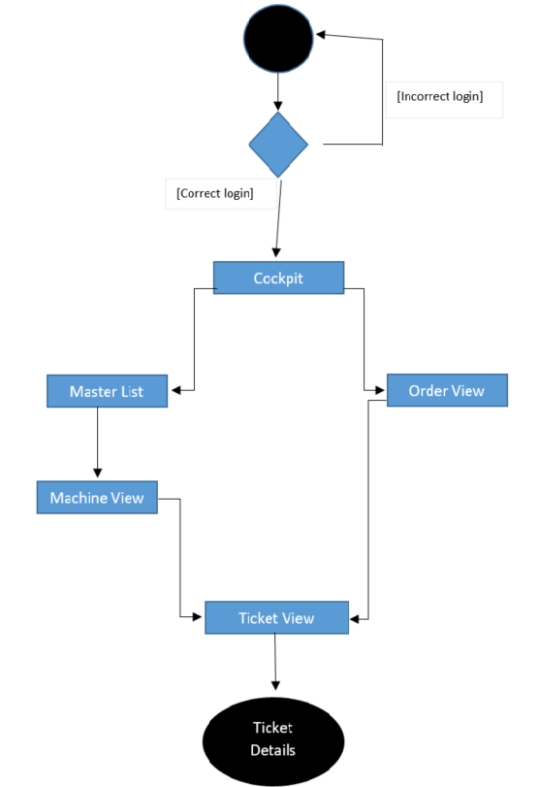

## 5.6 Sequence Diagram

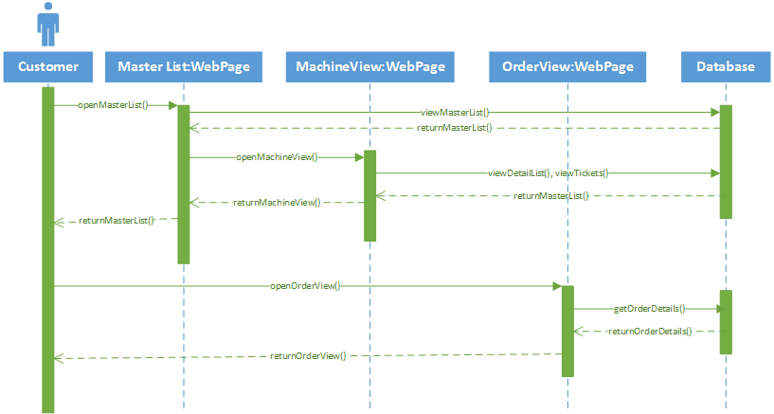

## 5.7 Alternative Designs and Design Rationale

## 5.8 Data Architecture

We will be getting information on the database side from the team at Inwerken soon.

# 6. User Interface

## 6.1 UI Description

## 6.2 UI Mockup

# 7. Project Closure

## 7.1 Goals / Vision

## 7.2 Delivered Solution

## 7.3 Remaining Work

# 8. Definitions and Acronyms

|  |  |
| --- | --- |
| **Term** | **Definition** |
|  |  |
|  |  |
|  |  |
|  |  |
|  |  |